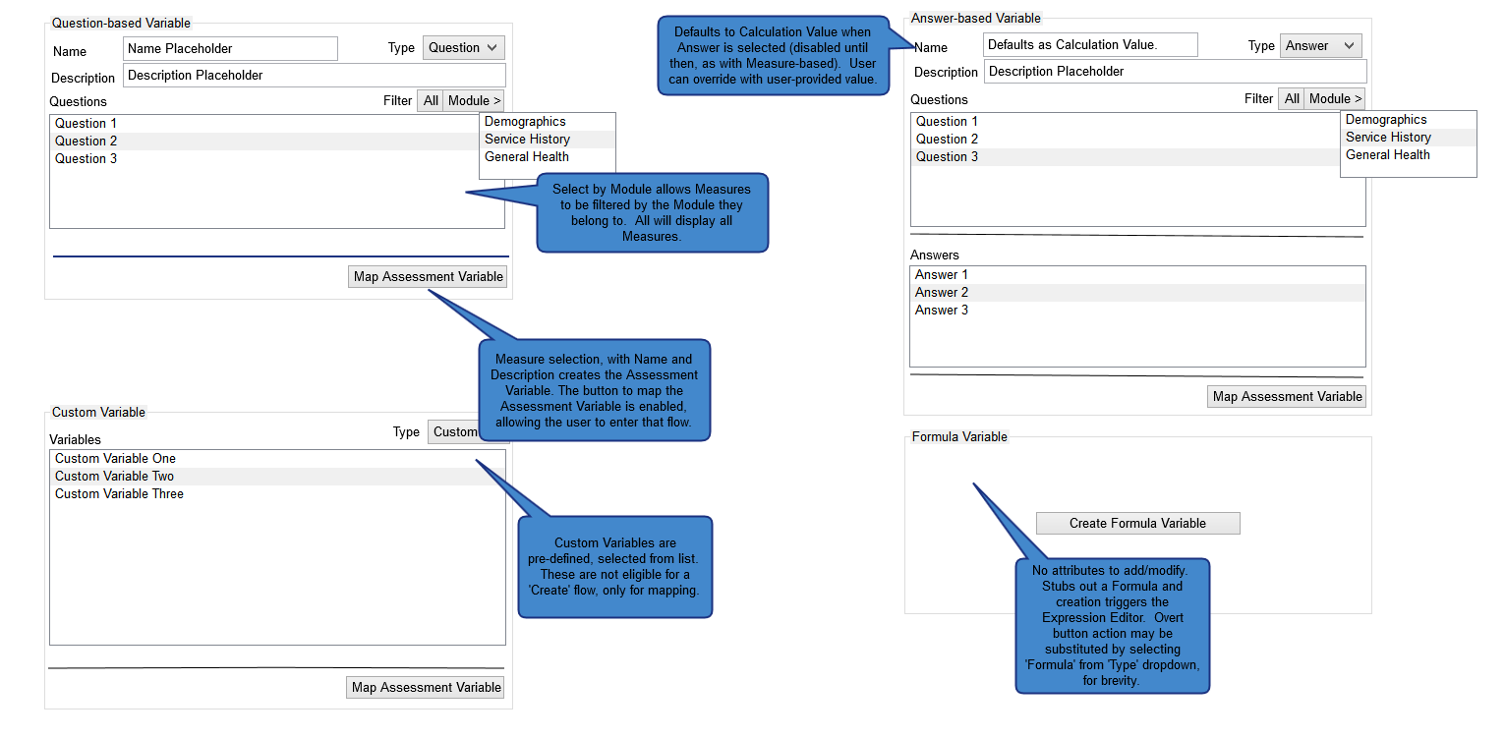

Figure 1: Create/Edit Variable

* For Formulas, the user has the ability to select the Creation and editing of Variables both from the Main navigation and in the context of the relevant view (i.e., Question). Two Variable Types, Question and Answer, are user-defined, whereas Custom Variables are pre-defined by the system, and can only be mapped, and Formula Variables contain no top-level properties, selection of which takes the user directly to the Expression Editor view. As with all lists, and with the exception of drag/drop sortability, the list is filtered by typeahead search and specific Type, as Variables of all types will be numerous. Paging controls will be visible for long lists, most likely with client control of paging.

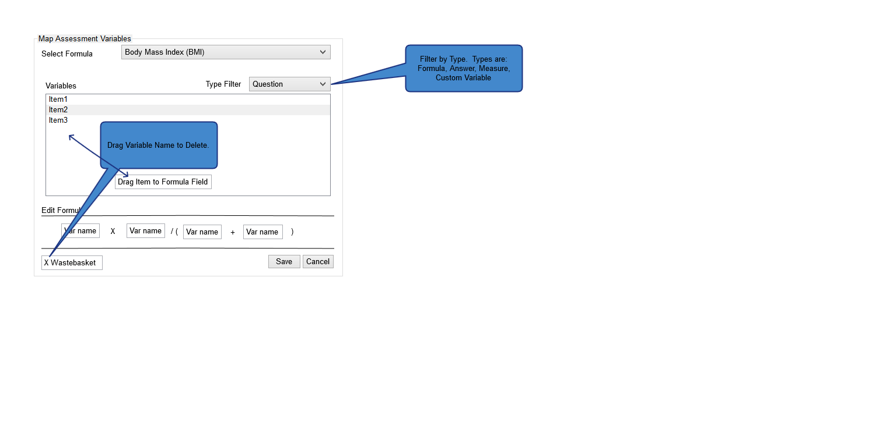

Figure 2: Map Assessment Variable

* This view can be triggered by direct context (i.e., an Answers, or other parent view) as a modal, or directly accessed by Variable creation/edit. The list of Variables can be sorted by Type, and paging controls for long list will be available for long lists.
* The user can drag and drop Variables into a Formula definition, filling out the association of calculated values to trigger Events, etc., tied to the Formula defined.

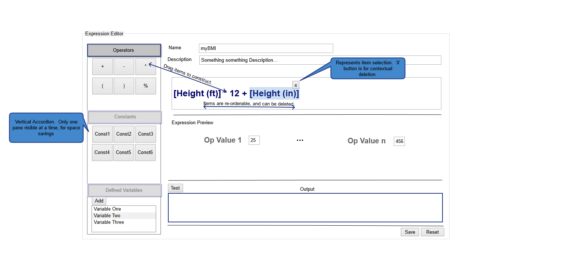

Figure 3: Expression Editor View

* In Expression Editor, the user can create a Formula to associate. Functionality is drag and drop to build the Formula, based on mathematical Operators, pre-defined Constants, and defined Variables for association (Question-specific, or otherwise). The user can test the Formula by providing dummy values for the variables, and view output, allowing the user to fine-tune complex formulas. Variables that are of type Formula that are already defined will be inline (useful in more complex, composited Formulas such as BMI).